**Blue & Golden Floral Separate Frames Metal Wall Art**

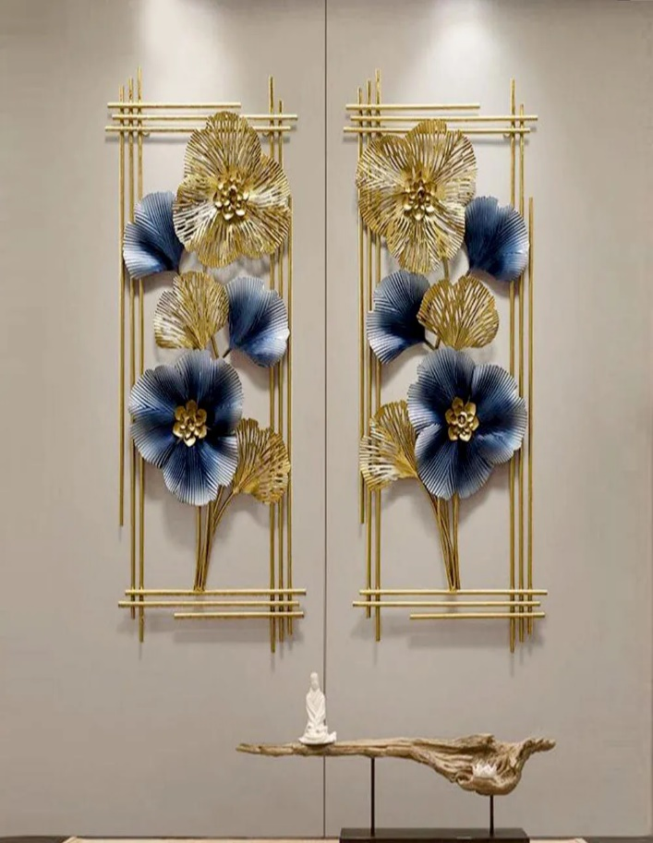Blue and golden floral separate frames metal wall art is a sophisticated and vibrant decor piece that blends color, nature, and modern design. Featuring individual frames, each showcasing a beautiful floral pattern in shades of blue and accented with golden details, this artwork creates a striking contrast between the serene cool tones and the luxurious warmth of gold. The metal construction ensures durability and a sleek finish, adding depth to the design. Ideal for spaces like living rooms, hallways, or bedrooms, these separate frames can be arranged creatively to form a unified display or hung individually to bring a touch of elegance and tranquility to your space.